Truncated Tetrahedron
# Source: AI Source: Provided by: [Data Path: Persons Table -> ID Column: 1, Name_En Column: Motasem Essam] -> From: [ChatGPT] on [7/25/2026]
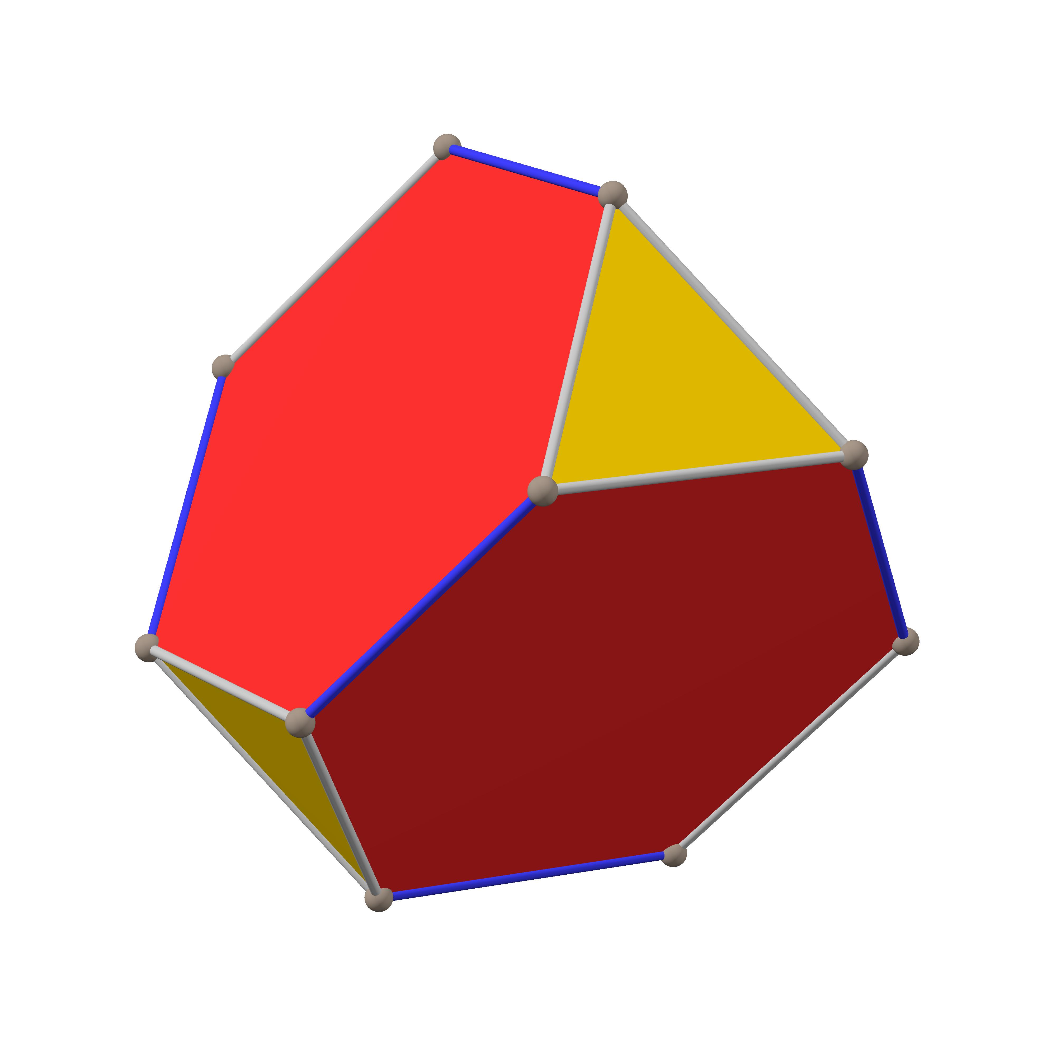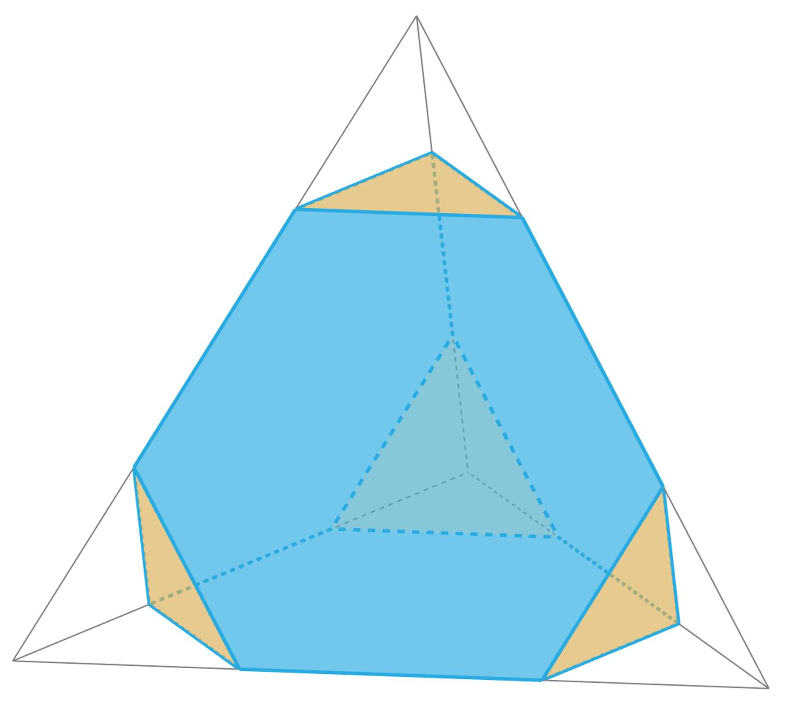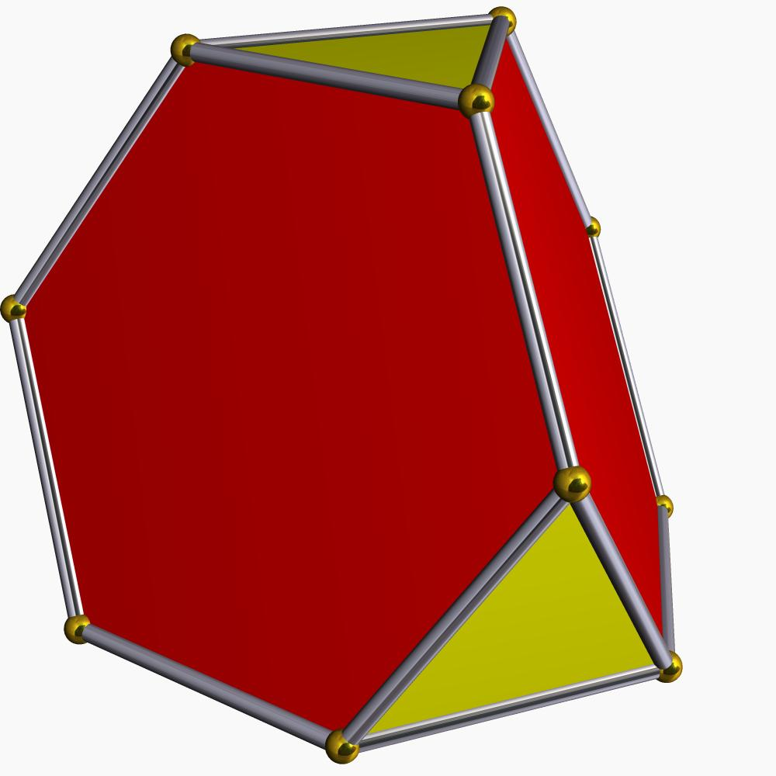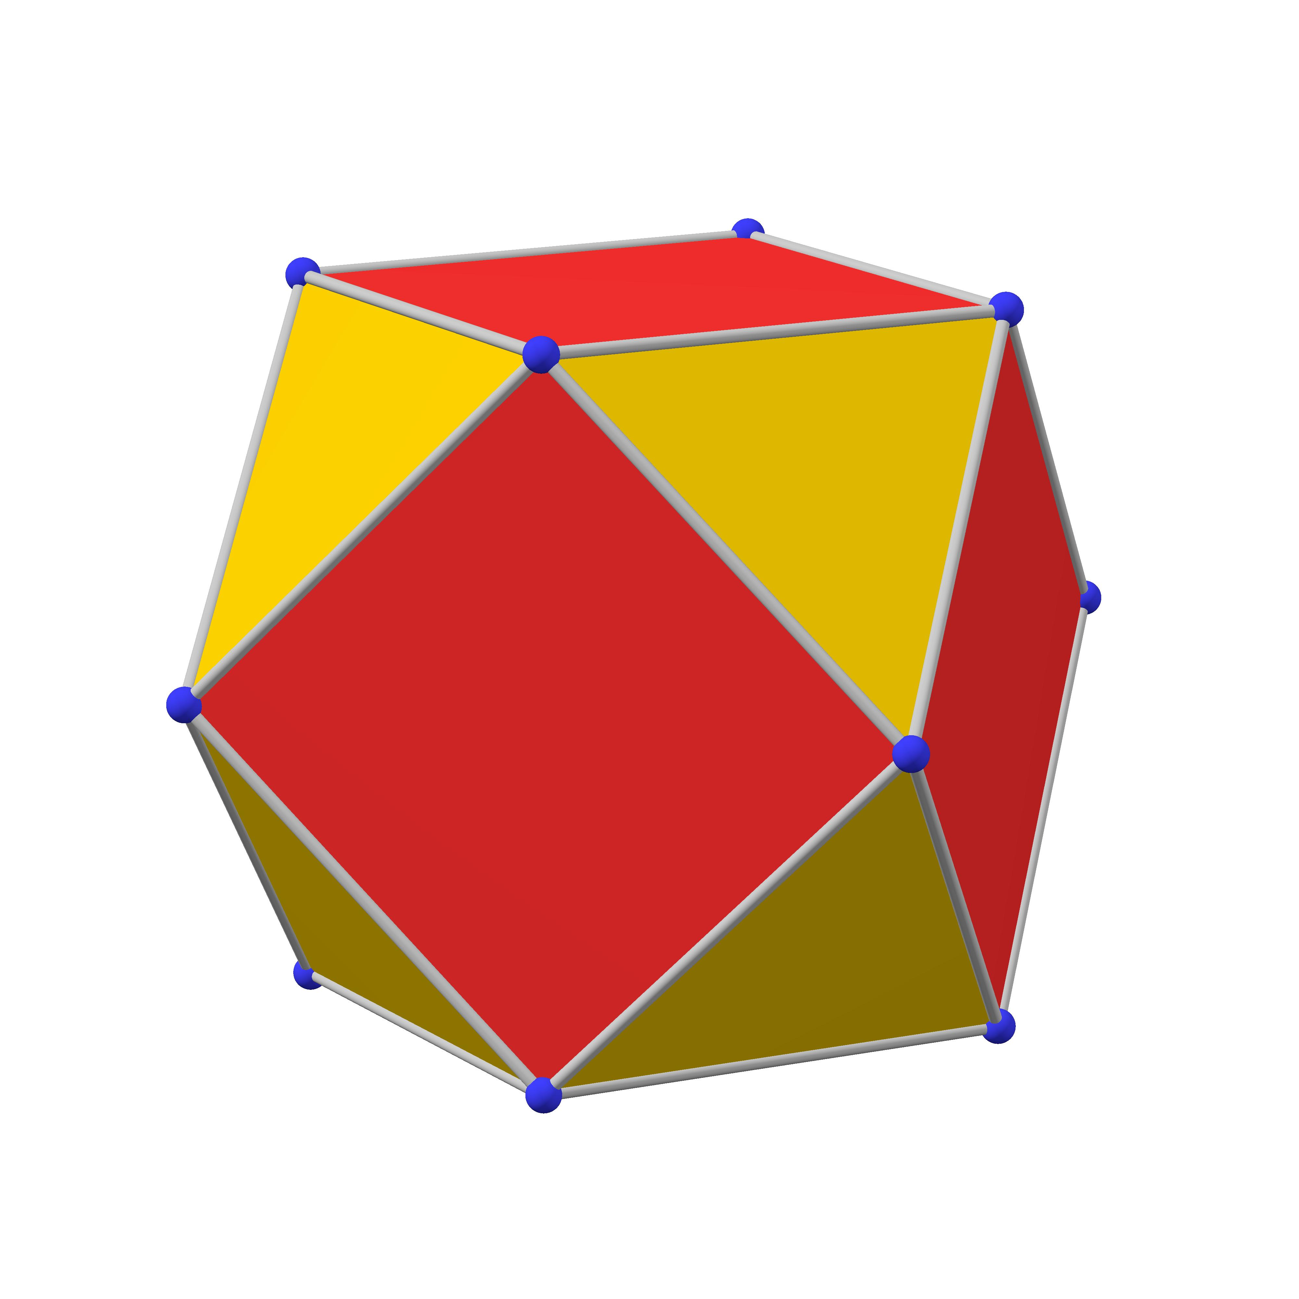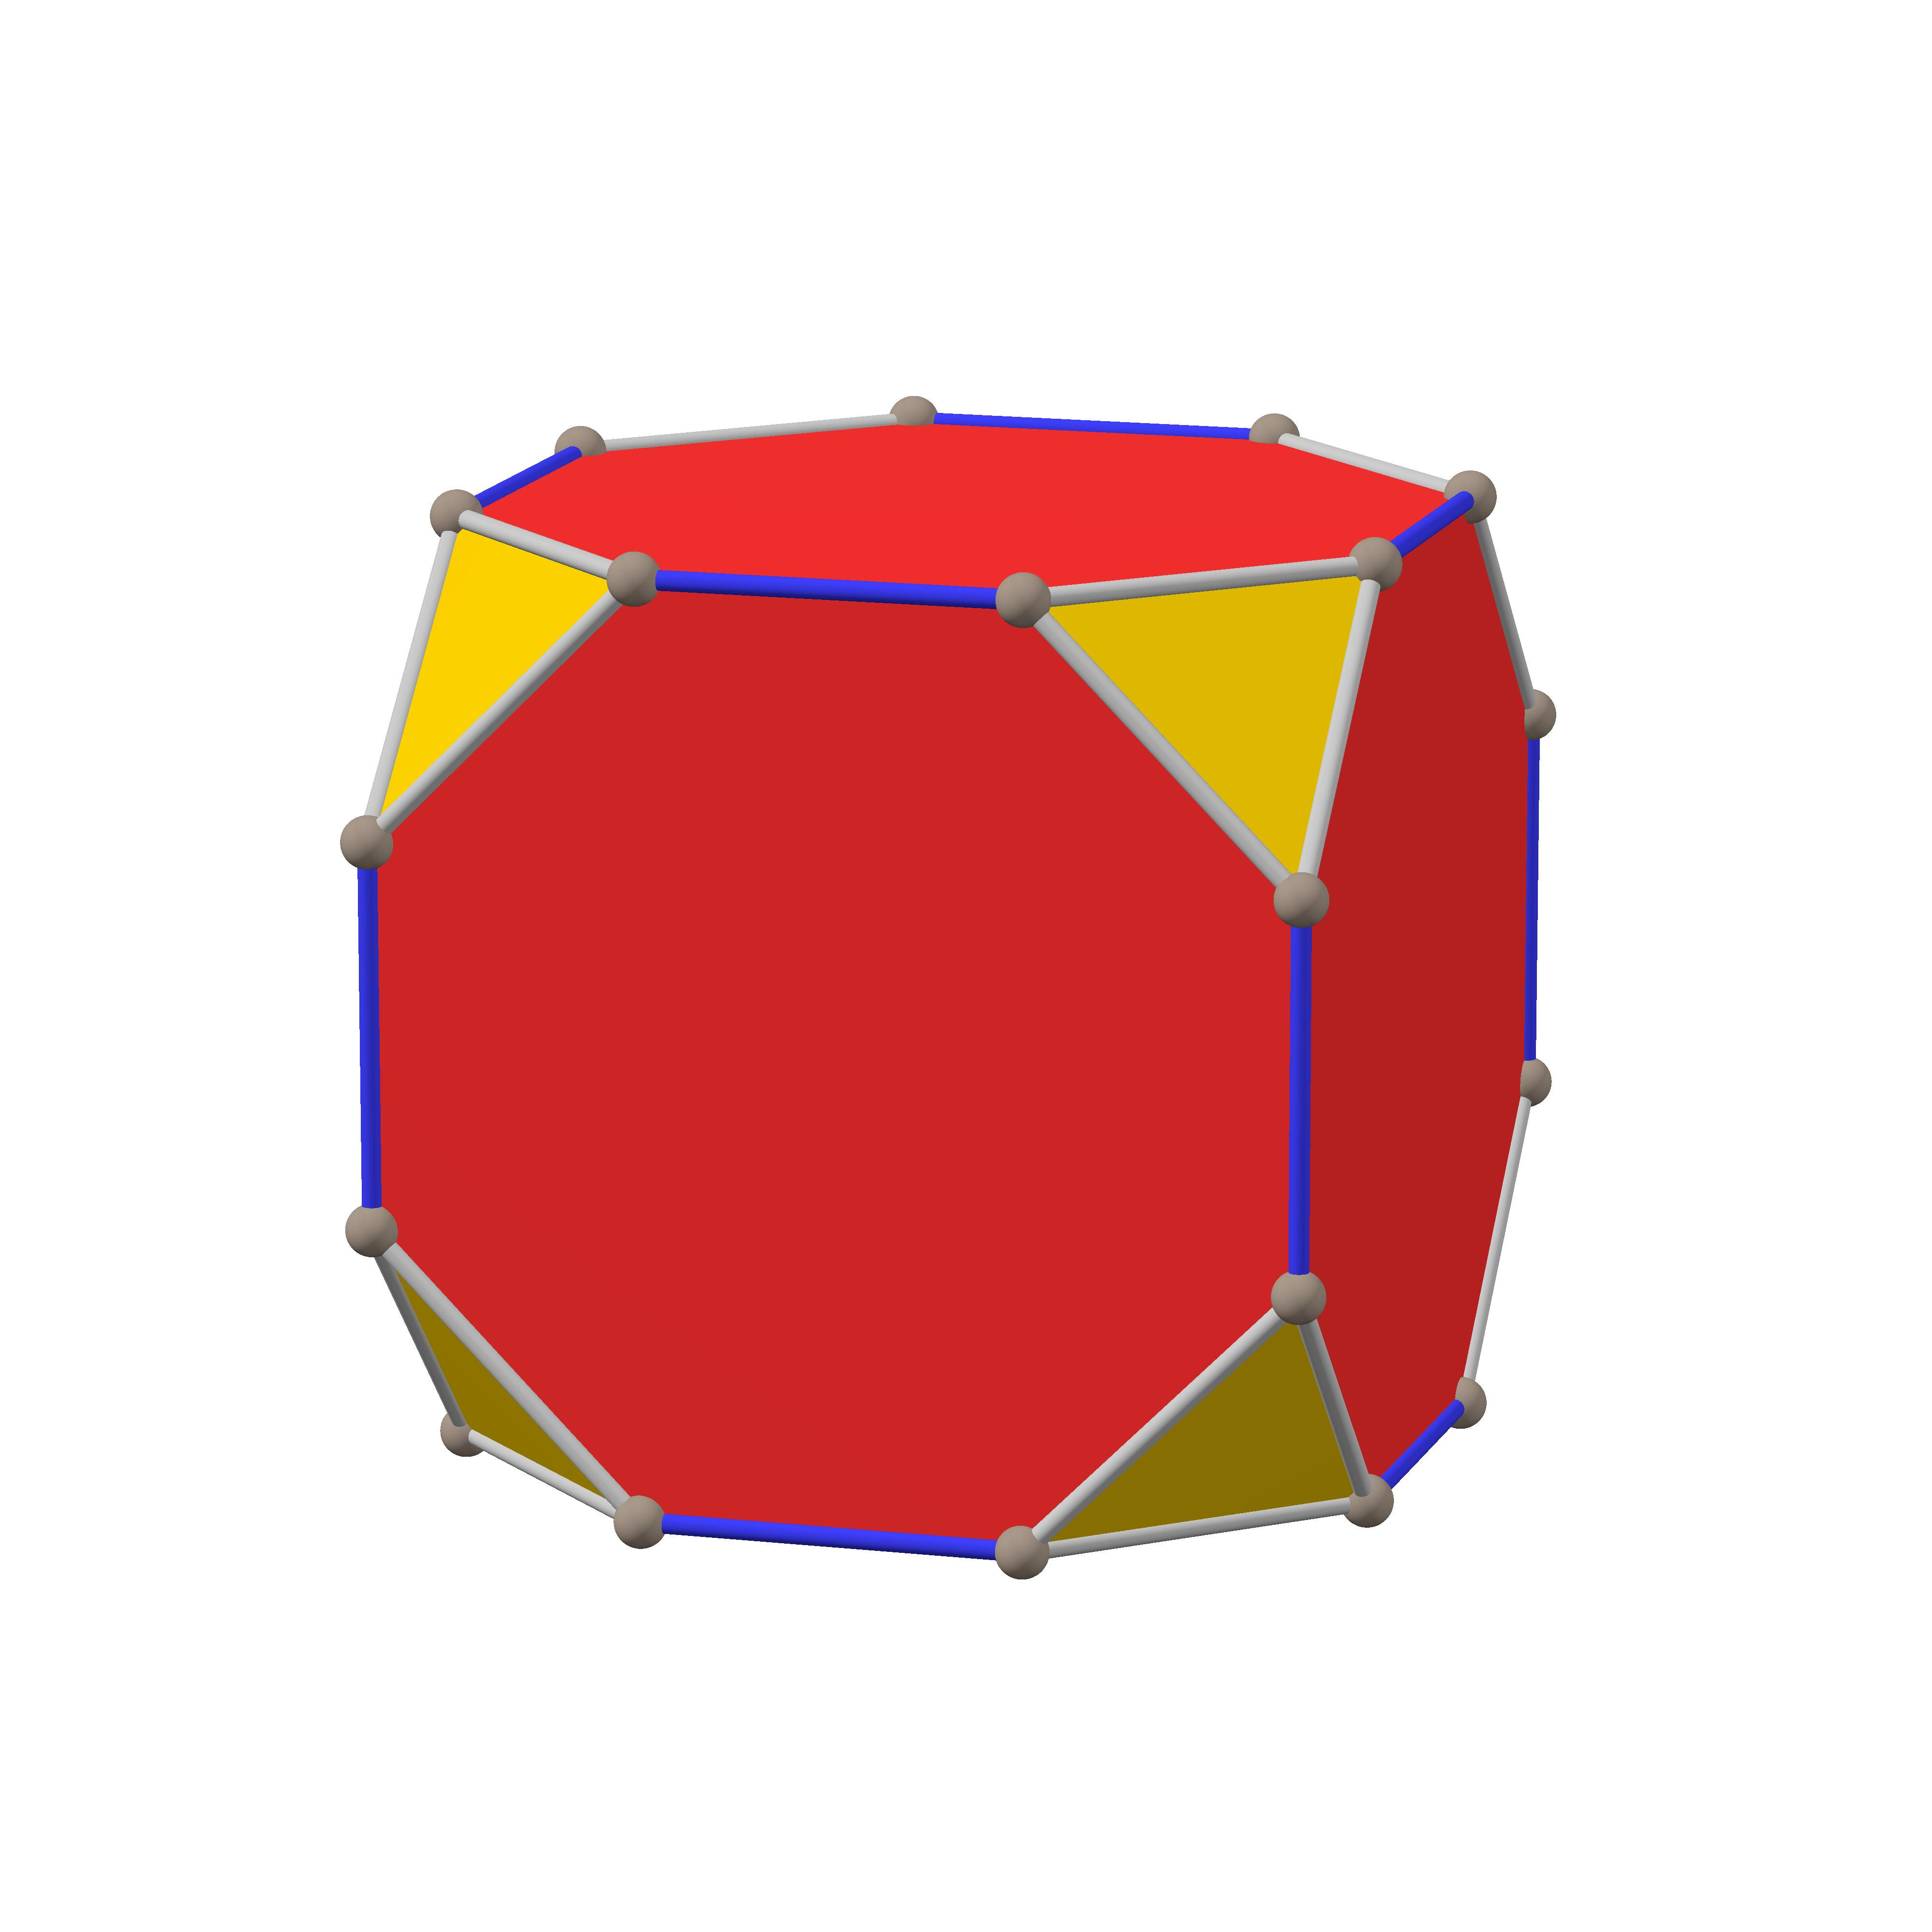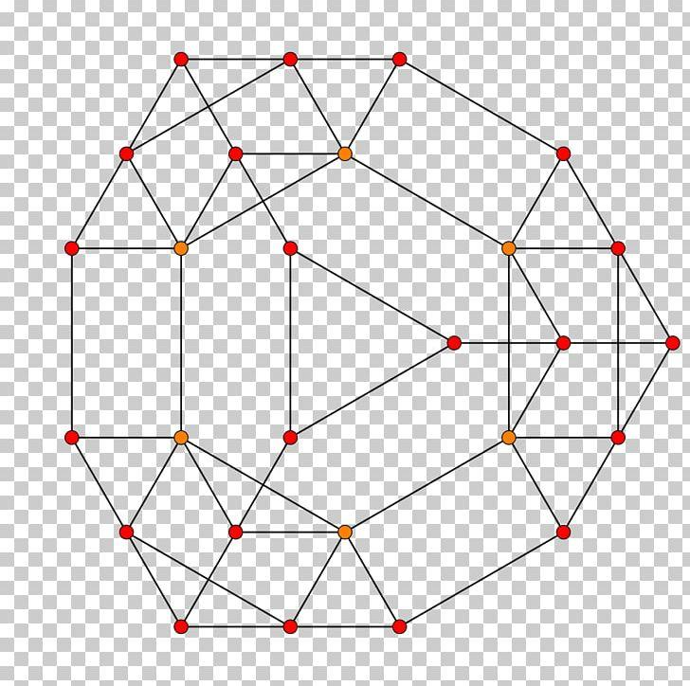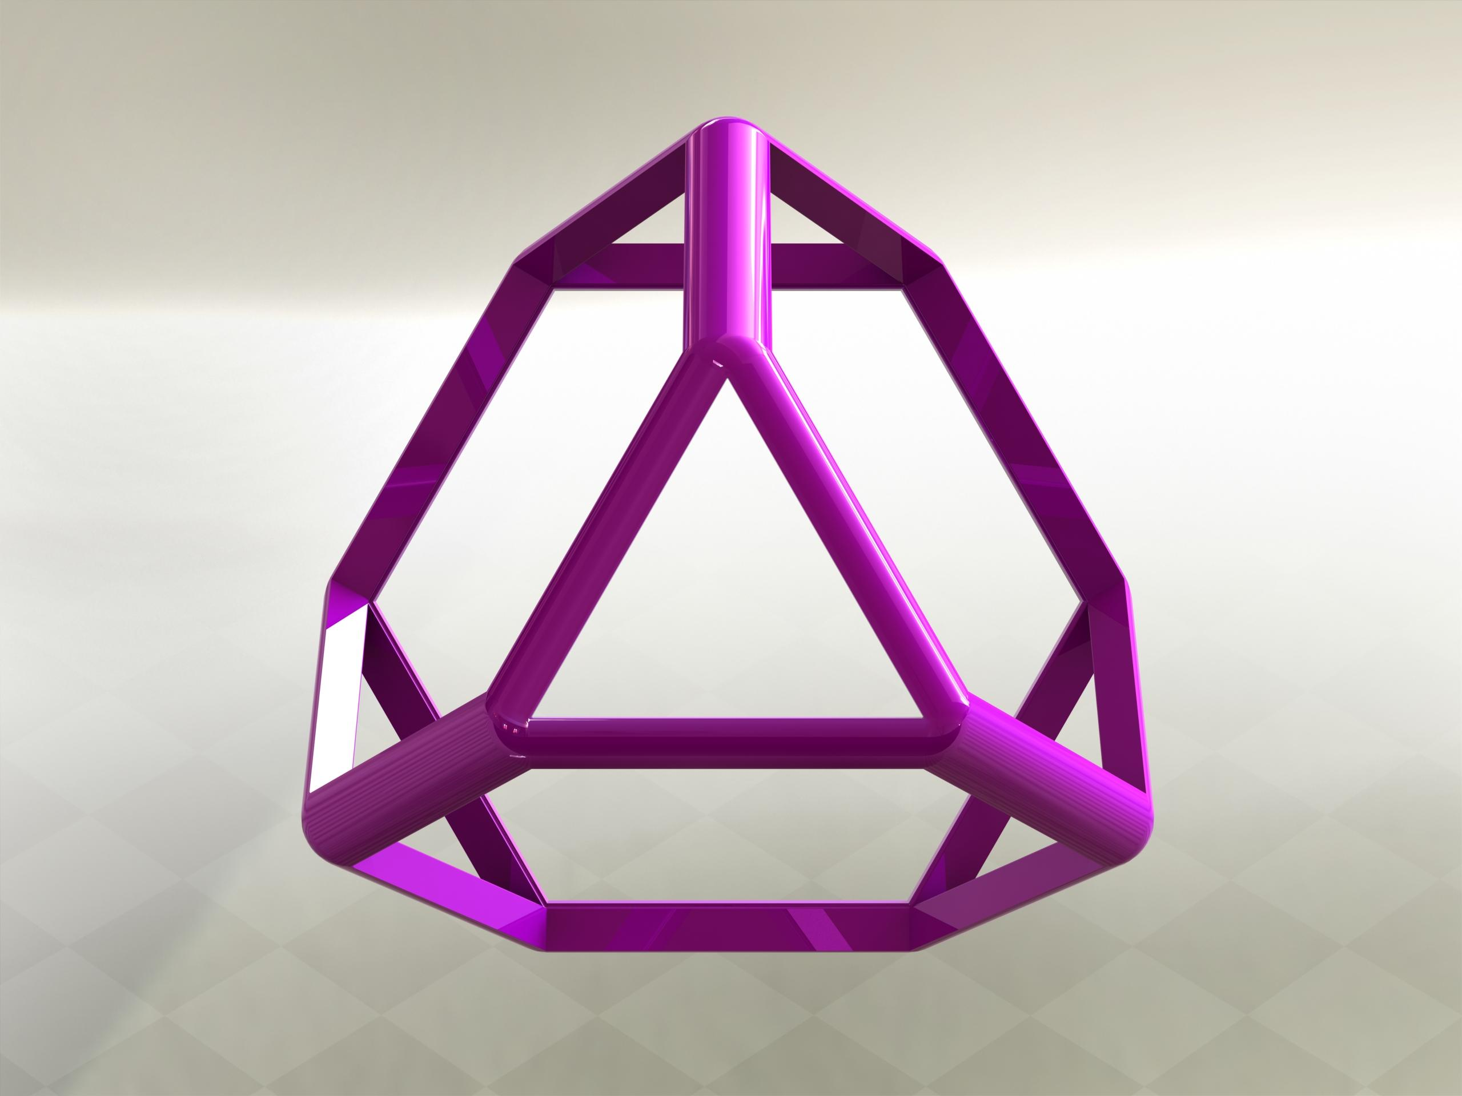

Definition
# Source: AI Source: Provided by: [Data Path: Persons Table -> ID Column: 1, Name_En Column: Motasem Essam] -> From: [ChatGPT] on [7/25/2026]
A Truncated Tetrahedron is a three-dimensional polyhedron formed by cutting off the four vertices of an original tetrahedron using planes.
The truncation process creates new triangular faces while modifying the original triangular faces into hexagons.

Geometric Characteristics
# Source: AI Source: Provided by: [Data Path: Persons Table -> ID Column: 1, Name_En Column: Motasem Essam] -> From: [ChatGPT] on [7/25/2026]
- Original Solid: Tetrahedron
- Original Vertices: 4
- New Faces: 4 triangles and 4 hexagons.
- Total Faces: 8
- Total Edges: 18
- Total Vertices: 12

Face Structure
# Source: AI Source: Provided by: [Data Path: Persons Table -> ID Column: 1, Name_En Column: Motasem Essam] -> From: [ChatGPT] on [7/25/2026]
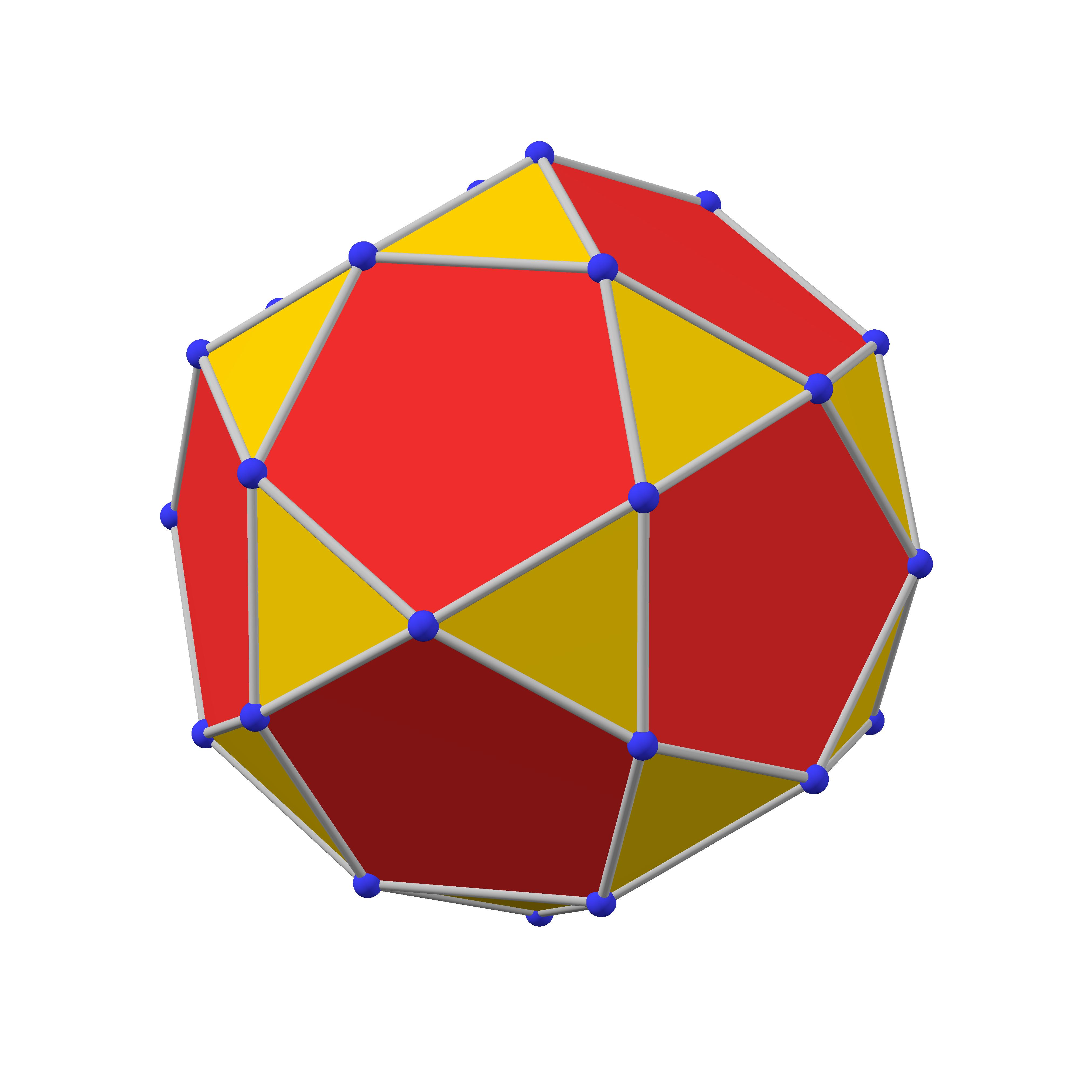
The truncated tetrahedron consists of:
- 4 Equilateral Triangular Faces: Created by cutting off the four original vertices.
- 4 Hexagonal Faces: Obtained by modifying the four original triangular faces of the tetrahedron.

Mathematical Properties
# Source: AI Source: Provided by: [Data Path: Persons Table -> ID Column: 1, Name_En Column: Motasem Essam] -> From: [ChatGPT] on [7/25/2026]
Let:
- $F$ = Number of faces
- $E$ = Number of edges
- $V$ = Number of vertices

Number of Faces
# Source: AI Source: Provided by: [Data Path: Persons Table -> ID Column: 1, Name_En Column: Motasem Essam] -> From: [ChatGPT] on [7/25/2026]
$$F=4+4=\boxed{8}$$

Number of Edges
# Source: AI Source: Provided by: [Data Path: Persons Table -> ID Column: 1, Name_En Column: Motasem Essam] -> From: [ChatGPT] on [7/25/2026]
$$E=\boxed{18}$$

Number of Vertices
# Source: AI Source: Provided by: [Data Path: Persons Table -> ID Column: 1, Name_En Column: Motasem Essam] -> From: [ChatGPT] on [7/25/2026]
$$V=\boxed{12}$$

Euler's Formula
# Source: AI Source: Provided by: [Data Path: Persons Table -> ID Column: 1, Name_En Column: Motasem Essam] -> From: [ChatGPT] on [7/25/2026]
For a convex polyhedron:
$$V-E+F=2$$
Substituting:
$$12-18+8=2$$
$$\boxed{2=2}$$
Therefore, the truncated tetrahedron satisfies Euler's formula.

Constructing Truncated Tetrahedron in Solid Geometry

Instruments Used
# Source: AI Source: Provided by: [Data Path: Persons Table -> ID Column: 1, Name_En Column: Motasem Essam] -> From: [ChatGPT] on [7/25/2026]
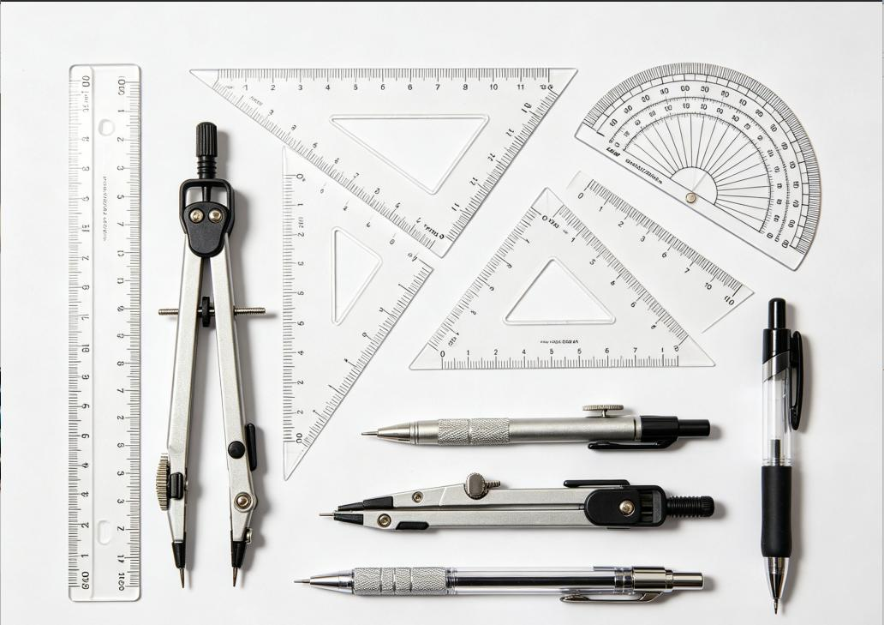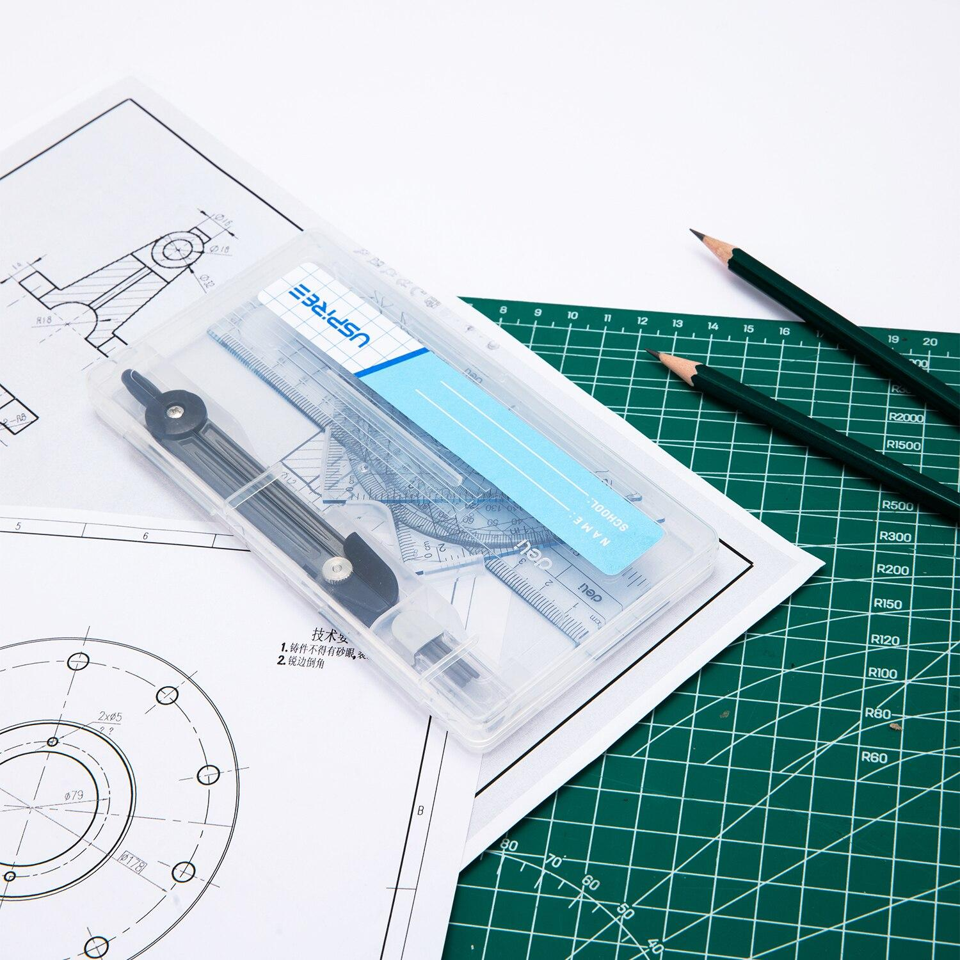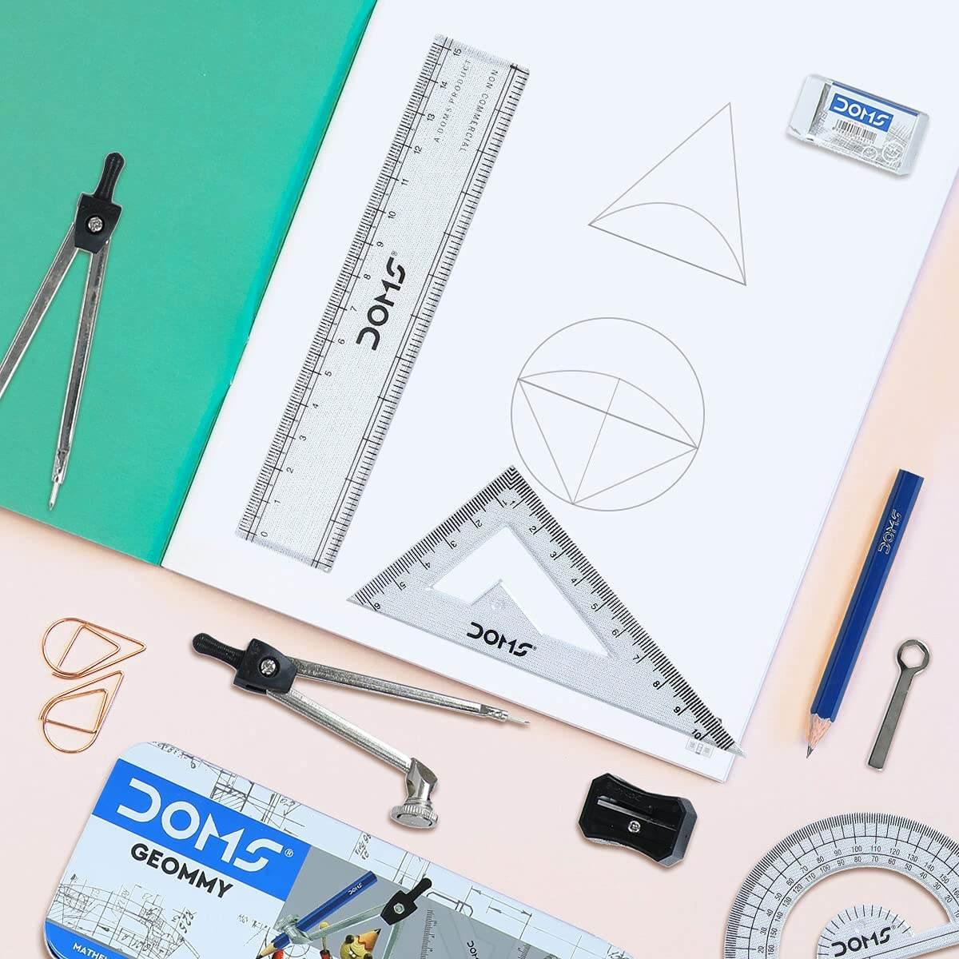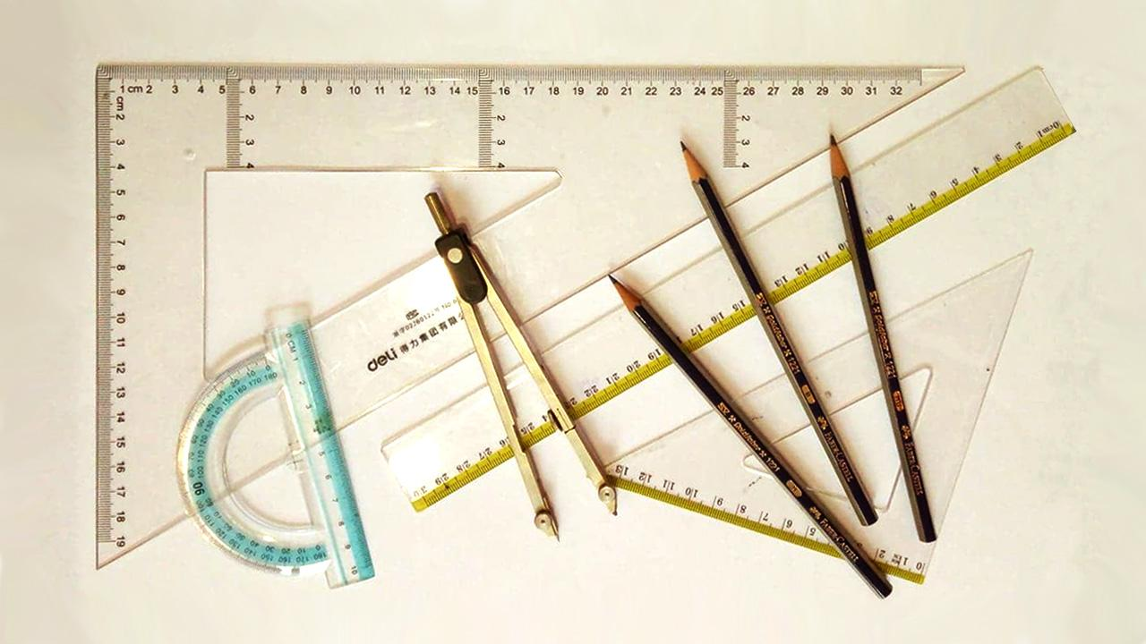
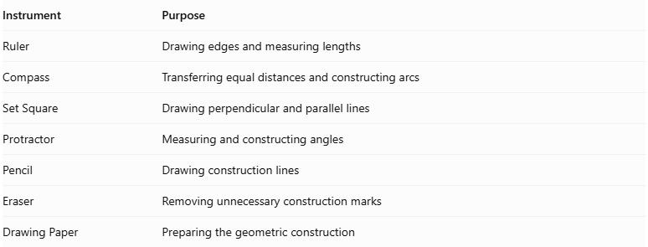
Instrument | Purpose
Ruler | Drawing edges and measuring lengths
Compass | Transferring equal distances and constructing arcs
Set Square | Drawing perpendicular and parallel lines
Protractor | Measuring and constructing angles
Pencil | Drawing construction lines
Eraser | Removing unnecessary construction marks
Drawing Paper | Preparing the geometric construction
Construction Method: Instrument-Based

Construction Procedures

Constructing the Original Tetrahedron
# Source: AI Source: Provided by: [Data Path: Persons Table -> ID Column: 1, Name_En Column: Motasem Essam] -> From: [ChatGPT] on [7/25/2026]
- Draw an equilateral triangular base using a ruler and compass.
- Locate the center of the triangular base using its medians.
- Construct a perpendicular line through the center.
- Mark the apex at the required height.
- Connect the apex to the three base vertices.
- Complete the regular tetrahedron using visible and hidden edge conventions.
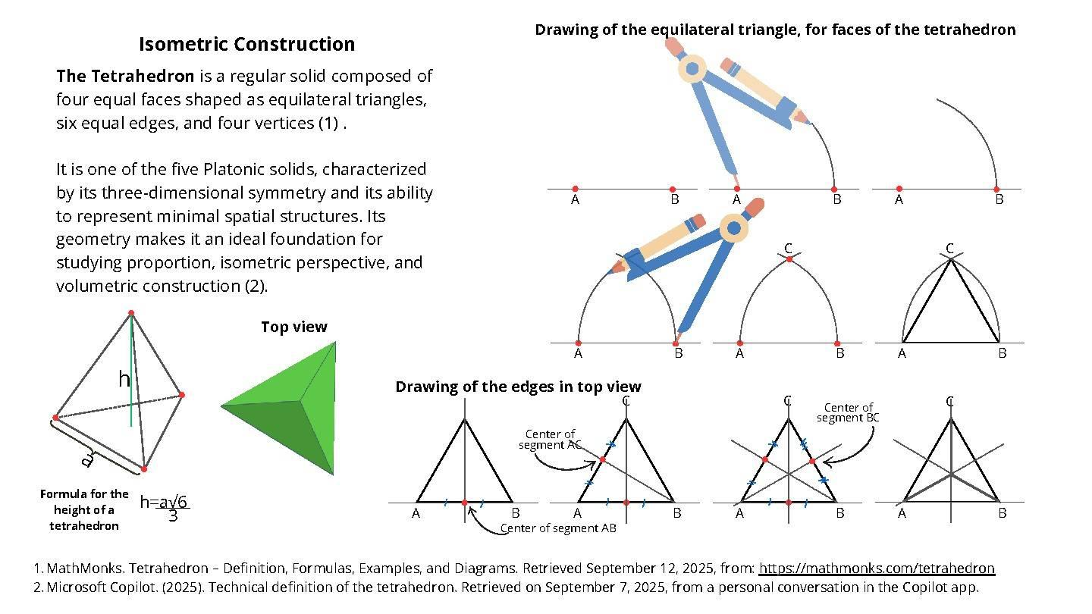

Marking the Truncation Points
# Source: AI Source: Provided by: [Data Path: Persons Table -> ID Column: 1, Name_En Column: Motasem Essam] -> From: [ChatGPT] on [7/25/2026]
- Identify the six original edges of the tetrahedron.
- Select the desired truncation depth.
- Measure equal distances from each endpoint along every edge.
- Mark the truncation points.
- For a regular truncated tetrahedron, measure one-third of the original edge length from each endpoint.
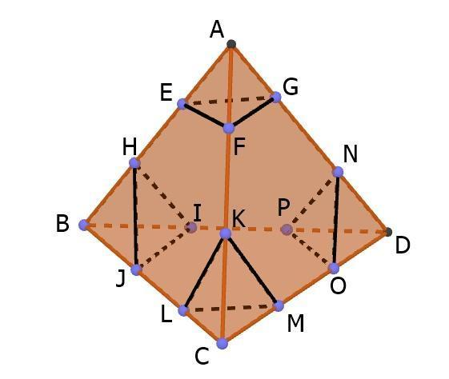

Constructing the Truncation Faces
# Source: AI Source: Provided by: [Data Path: Persons Table -> ID Column: 1, Name_En Column: Motasem Essam] -> From: [ChatGPT] on [7/25/2026]
- At each original vertex, identify the three truncation points on its three incident edges.
- Connect these three points to form a triangular truncation face.
- Repeat the procedure for all four original vertices.
- Ensure that the four new triangular faces are congruent in the regular construction.
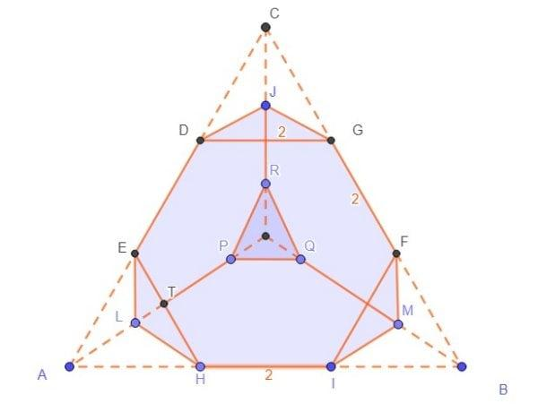

Constructing the Modified Original Faces
# Source: AI Source: Provided by: [Data Path: Persons Table -> ID Column: 1, Name_En Column: Motasem Essam] -> From: [ChatGPT] on [7/25/2026]
- Identify the remaining portions of the original four triangular faces.
- Connect the truncation points in their correct boundary order.
- Construct the resulting hexagonal faces.
- Verify that each hexagon has six edges.
- For a regular truncated tetrahedron, ensure that all hexagonal faces are regular.
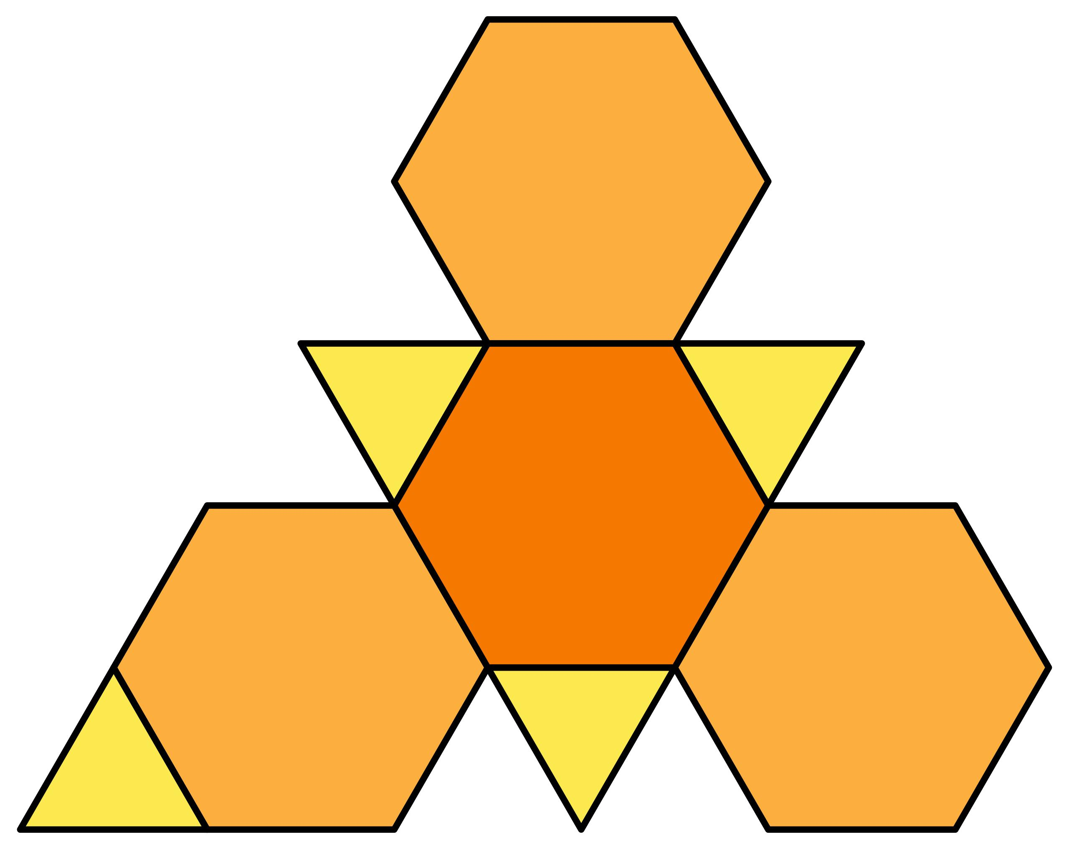

Completing the Truncated Tetrahedron
# Source: AI Source: Provided by: [Data Path: Persons Table -> ID Column: 1, Name_En Column: Motasem Essam] -> From: [ChatGPT] on [7/25/2026]
- Connect all corresponding truncation points.
- Complete the four triangular faces and four hexagonal faces.
- Draw visible edges using solid lines.
- Draw hidden edges using dashed lines where appropriate.
- Verify the final solid has 8 faces, 18 edges, and 12 vertices.
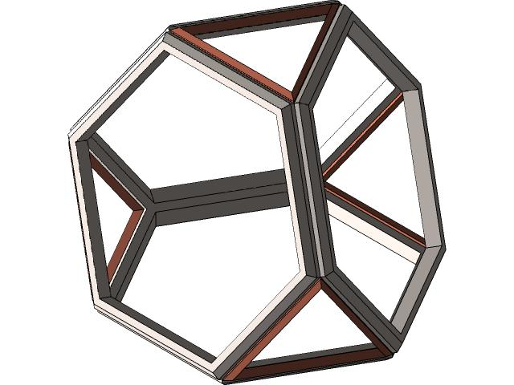

Constructing the Net of a Regular Truncated Tetrahedron
# Source: AI Source: Provided by: [Data Path: Persons Table -> ID Column: 1, Name_En Column: Motasem Essam] -> From: [ChatGPT] on [7/25/2026]
- Draw four regular hexagons representing the modified original faces.
- Arrange them in the correct connected pattern.
- Attach four equilateral triangles to the appropriate hexagon edges.
- Ensure that each edge belongs to exactly two faces after assembly.
- Add joining flaps if the net is intended for physical assembly.
- Cut and fold the net to form the truncated tetrahedron.
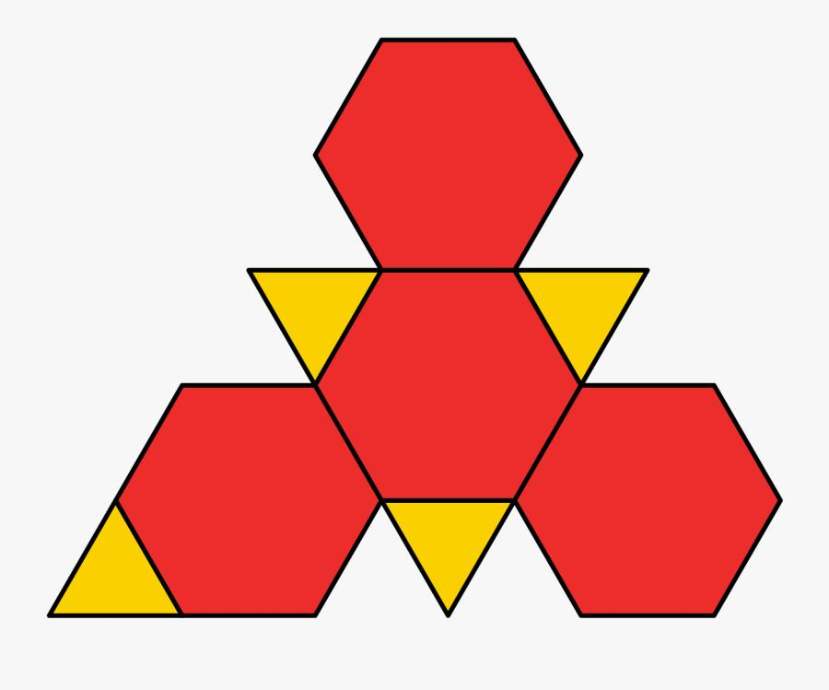

Key Points
# Source: AI Source: Provided by: [Data Path: Persons Table -> ID Column: 1, Name_En Column: Motasem Essam] -> From: [ChatGPT] on [7/25/2026]
- It is formed by truncating the four vertices of a tetrahedron.
- It has 4 triangular faces and 4 hexagonal faces.
- It has 8 faces, 18 edges, and 12 vertices.
- Each original vertex produces one new triangular face.
- Each original triangular face becomes a hexagonal face.
- It is an Archimedean solid when uniformly truncated.

Conclusion
# Source: AI Source: Provided by: [Data Path: Persons Table -> ID Column: 1, Name_En Column: Motasem Essam] -> From: [ChatGPT] on [7/25/2026]
The truncated tetrahedron is a three-dimensional geometric solid obtained by cutting off the four vertices of a regular tetrahedron. It consists of four equilateral triangles and four regular hexagons, creating a symmetrical solid with 8 faces, 18 edges, and 12 vertices.

